**Protecting Seniors from Cyber Scams in Malaysia**

Today's digital era has made cyber scams much more sophisticated, with these cases targeting society's most vulnerable group: the elderly. In Malaysia, as more elderly become active online to maintain communication with relatives or manage their finances, they're also vulnerable to becoming cyber fraud victims.

**Why Are Seniors in Malaysia More Vulnerable?**

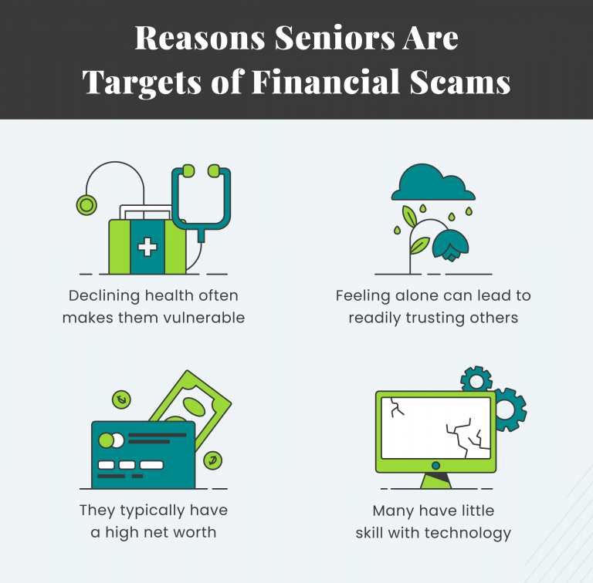

The elderly are commonly targeted by a mix of health, emotional, and technological reasons. From cyber security awareness reports, the below-listed reasons make elderly people a special target:

* **Declining Health**: Illness or cognitive decline can reduce judgment, making it easier for scammers to manipulate seniors.
* **Loneliness**: Many seniors live alone or are isolated, leading them to trust strangers more easily — especially online “friends.”
* **Financial Assets**: Seniors are perceived as having significant savings, making them attractive targets.
* **Lack of Tech Savviness**: Older adults may struggle with identifying phishing emails, scam calls, or fake websites.

**The Reality of Cyber Scams in Malaysia**

The **Royal Malaysia Police (PDRM)** and **CyberSecurity Malaysia** have reported an uptick in online scam cases targeting elderly Malaysians. These involve:

* **Phone Scams (“Macau Scams”)** where scammers pose as bank officers or law enforcement.
* **Investment Scams** that promise unrealistic returns.
* **Romance Scams** via Facebook or messaging apps.
* **Phishing Scams** through fake emails impersonating government or financial institutions.

Between January and August 2024, 1,916 elderly Malaysians aged 61 and above fell victim to online scams, resulting in a loss of **RM255 million** in total, as reported by the **Bukit Aman Commercial Crime Investigation Department**.

**🧠 Awareness and Prevention: What Can You Do?**

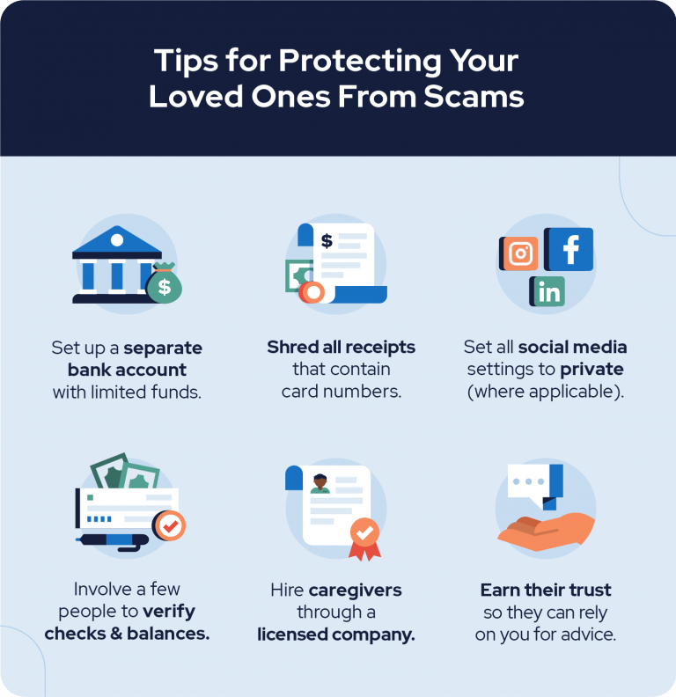

Here are **practical tips** families and caregivers can take to protect elderly loved ones:

1. **Separate Bank Accounts**: Limit potential losses by maintaining accounts with minimal balances for online transactions.
2. **Shred Personal Documents**: Discard old receipts, credit card slips, and personal documents securely.
3. **Privacy Settings**: Help seniors set their **Facebook, Instagram, and WhatsApp** settings to private.
4. **Involve Trusted Contacts**: Have at least one or two family members regularly verify bank or transaction activities.
5. **Hire Legitimate Caregivers**: Use registered and reputable agencies when hiring help at home.
6. **Build Trust**: Talk to seniors frequently. If they trust you, they’re more likely to ask before engaging in suspicious interactions.

**Real Stories, Real Lessons**

**RM552.5 million in loss by senior citizens (2021–2023): The Royal Malaysia Police (PDRM)** reported that 6.4% of scam victims were senior citizens, while they bore 20% of total loss, totaling **RM2.7 billion**, during this time.

**RM780 million lost by victims above age 50 in 2024:** The most affected group in cyber fraud cases was people over age 50, with 54% of the total loss amounting to **RM1.45 billion** reported as at December 15, 2024.

**Government & NGO Efforts**

To combat this issue, initiatives like measures such as **CyberSAFE Malaysia, Klik Dengan Bijak (Click Wisely),** and campaigns conducted by **MCMC** with the objective to promote online fraud awareness, especially among senior citizens. Free seminars and hotline services such as **CCID Scam Response Center (03-26101559/1599)** are also provided.

**Conclusion**

Protecting Malaysian elders from cyber fraud is everybody's responsibility. Regardless of whether you're a community leader, a member of a family, or a tech-savvy youth, **a mere conversation may save an individual from becoming a victim**.  
**Remember**: Prevention and constant support are essential in ensuring our elderly are safe online.

**References**

<https://www.malay.news/bukit-aman-elderly-online-scam-victims-lose-rm255m-as-fraud-cases-surge-in-2024>

<https://www.thestar.com.my/news/nation/2024/05/27/bukit-aman-senior-citizens-made-up-20-of-rm27bil-lost-to-scams-in-2021-2023-period>

<https://themalaysianreserve.com/2024/12/18/victims-aged-50-and-above-suffer-highest-losses-in-online-fraud-cases-ccid>